Experimental Report
Course name | Digital Image Processing
Student number | 2011561103 | Name | MD MUSTAFIZUR RAHMAN
Major | CST | Class | 20 LC
Experiment Date | 22-10-26
Experimental content | Experiment 4 : Image Restoration and Segmentation
1．Purpose and tasks of the experiment

The main purpose and task of this experiment is to become familiar and mastering with the use of MATLAB image processing toolbox. Understand and become the master of commonly used of image restoration and segmentation techniques.

2. Experimental steps and results

Describe the basic steps and main codes of the experiment and give the experimental results with pictures.
(Delete the red word when submitting the report)

step-1 is generate motion blurred images and apply Wiener filtering for image restoration. Use Wiener filter algorithm to restore image I and return to image J. I is an N-dimensional array, PSF is the convolution of the point spread function. NSP is the noise-to-signal power ratio of additive noise.
I=imread('1.jpg')
I=rgb2gray(I)
I = im2double(I); % Simulate motion blur
LEN = 21; THETA = 11;
PSF = fspecial('motion', LEN, THETA);
blurred = imfilter(I, PSF , 'conv', 'circular'); % restore image
wnr2 = deconvwnr(blurred, PSF);
subplot(1,2,1);imshow(blurred);title('motion blurred image')
subplot(1,2,2);imshow(wnr2);title('restore image')

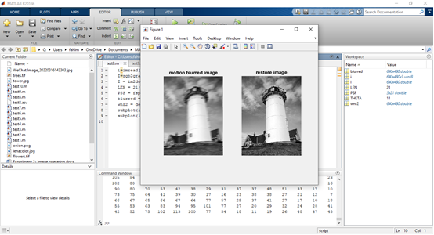

step-2 is using three different operators to detect image edges. Detects edges in a grayscale or binary image and returns a binary image where 1 pixel is a detected edge and 0 pixel is a non-edge.
Usage:
BW = edge(I,'sobel',thresh,direction)
I is the detection object; The edge detection operator can be used sobel , roberts , prewitt , zerocross , log , canny ;Thresh specifies the threshold, ignores all edges smaller than the threshold during detection, and automatically selects the threshold by default; direction, in the specified direction, uses the specified operator to perform edge detection

BW1 = edge(I,'prewitt');
BW2 = edge(I,'zerocross');
BW3 = edge(I,'canny');
subplot(2,2,1);
imshow(I);title(' original image ')
subplot(2,2,2);
imshow(BW1);
title(' prewitt edge map ')
subplot(2,2,3);
imshow(BW2);
title('zerocross edge map ')
subplot(2,2,4);
imshow(BW3);
title(' canny edge map ')

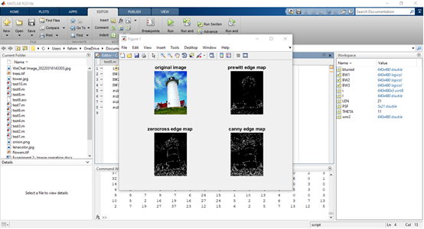

Step-3is performing the dilation and erosion operations of the square template 3*3 and 5*5 respectively on the binary image.
usage：
a=imread('1.jpg');
I = rgb2gray(a);
I = im2bw(a,0.5);
se3 = strel('disk',3);
erodedBW1 = imerode(I,se3);
se4 = strel('disk',5);
erodedBW2 = imerode(I,se4);
se1 = strel('ball',3,3);
I1 = imdilate(a,se1);
se2 = strel('ball',5,5);
I2 = imdilate(a,se2);
figure,subplot(2,2,1);imshow(I1);title('3*3 inflated image ')
subplot(2,2,2);imshow(I2);title('5*5 inflated image ')
subplot(2,2,3);imshow(erodedBW1);title('3*3 Corroded image ')
subplot(2,2,4);imshow(erodedBW2);title('5*5 Corroded image ')

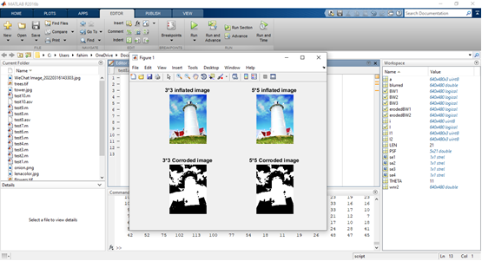

3. Experimental experience

It means your feelings and your harvest

This is my fourth experiment of MATLAB and this one is the most interesting experiment. We perform three steps to complete this experiment. Actually, it is really fun for me to make a single image in different filtering, restoring etc. by using coding. After doing this experiment, now I become much familiar and master of the MATLAB image processing toolbox and also understand the commonly use of image restoration and segmentation techniques.

